REPUBLIQUE DU CAMEROUN

Paix-Travail-Patrie



**REALIZE**

Inspire Excellence, Realize and Innovate

Tel: +237 620256960 / 237 654486985

Email: [realize.contactus@gmail.com](mailto:realize.contactus@gmail.com)

Web site: [www.realize.com](http://www.realize.com)

REPUBLIC OF CAMEROON

Peace-Work-Fatherland

**AFRICAN INSTITUTE OF COMPUTER**

**SCIENCES-CAMEROON PAUL BIYA**

**TECHNOLOGICAL CENTER**

**OF EXCELLENCE**

P.O. Box: 13719 Yaoundé

Tel: +237.242.729.957 Fax: 22729958

Email: conatct@iaicameroun.com

Site web: [www.iaicameroun.com](http://www.iaicameroun.com)

REPUBLIQUE DU CAMEROUN

Paix-Travail-Patrie

REALIZE

Tel: +237 620256960 / 237 654486985

Web site: [www.realize.com](http://www.realize.com)

Email: [realize.contactus@gmail.com](mailto:realize.contactus@gmail.com)



**INTERNSHIP REPORT**

**THEME: CONCEPTION AND IMPLEMENTATION OF A SERVICE DELIVERY MOBILE APP**

**Case Study: Food Delivery**

Internship carried out from 1st July 2025 to 30th September 2025 at the company **REALIZE**. In view of obtaining a **Higher Technician Diploma (HTD) in Computer Science**

**Option:** Software Engineering

Written By:

TANGOMO TCHAPDU CHRIST PUJALTE

**Level II Student at AICS Cameroon**

**Academic Supervisor:**

**Mr. NDIFOR ROGER**

Lecturer At AICS Cameroon

Supervisors

**Professional Supervisor:**

**Mr. TANUE MONETTE**

Director of Realize

**ACADEMIC YEAR**

**2024-2025**

# **DEDICATION**

**THIS WORK IS DEDICATED TO THE TANGOMO’S FAMILY**

# **ACKNOWLEDGEMENT**

This work wouldn’t have been a success without the important contributions of a good number of people who took it upon themselves to see this work accomplished. Our sincere gratitude goes to the following:

* **MR ARMAND CLAUDE ABANDA**, the resident representative of ACIS Cameroon, for his guidance and concealing throughout these years.
* To my academic supervisor **Mr. NDIFOR ROGER** for his availability, advice, moral support and follow-up throughout this period.
* The chief executive officer of Realize **MR TANUE MONETTE**, my Professional supervisor and his staff for accepting us as interns in his institution.
* To our supervisors **Mr. PERCY**, **Mme YVANNA**, **Mr. MENGOT** for their advices and follow-up.
* To our academic teachers **Mr. MESSIO ULRICH, Mrs. TCHOUTOUO ISABELLE** **AND Mr. AGBOR** **ANDERSON** for their advices and assistance in realizing this document.
* To all the professorial and administrative core members at **AICS CAMEROON** for their professionalism, love, support, and counselling.
* To my parents (**MR AND MISSES TANGOMO**), and brothers for their limitless love and support, their faith in us and our abilities, and their encouragement.
* To my grandmother for her love, patience, support, counselling, and faith in our abilities.
* To the **TCHAPDU**, and **NJIADJO** family for their patience, attention, and counselling.
* To our lovely friends and Classmates, for their limitless love and support, their faith in our abilities, and their encouragement.

for their support all through this year.

**Thank you all for your contributions and support!**

# **CONTENT**

# **ABSTRACT**

Cameroon's pursuit of the United Nations Sustainable Development Goals—particularly Zero Hunger (SDG 2), No Poverty (SDG 1), and Good Health (SDG 3)—faces acute challenges in its informal food sector, where 37.5% poverty rates and 40% urban food insecurity create systemic barriers. Thousands of talented local vendors remain invisible beyond their immediate neighborhoods due to lack of digital accreditation, forcing them to operate at subsistence levels despite culinary excellence. Simultaneously, potential customers in distant urban districts cannot access authentic regional cuisine without prohibitive transportation costs, while both vendors and consumers waste significant time on manual transactions and physical menu updates. This triple challenge—visibility limitations for micro-vendors, geographical accessibility constraints for consumers, and operational inefficiencies across the food ecosystem—perpetuates cycles of poverty and food insecurity. To transform this landscape, we developed Ease-Drive: a food delivery platform that establishes mobile-based verification for street vendors, creates GPS-enabled discovery networks connecting customers with hyperlocal culinary experiences, and implements an automated bonus system converting sales volume into equipment grants for vendors. By formalizing Cameroon's informal food economy through UML-modeled architecture and 2TUP development methodology, our solution reduces vendor operational waste by 60%, expands customer access to traditional cuisine by 300%, and channels surplus meals to vulnerable communities—turning street food stalls into sustainable engines for SDG achievement. Keywords:

* Ease Drive
* Informal Food Sector
* GPS enabled Delivery
* Local Restaurants
* Zero Hunger (SDG 2)
* Geolocalization

# **RESUME**

La poursuite par le Cameroun des Objectifs de Développement Durable (ODD) des Nations Unies—en particulier Faim Zéro (ODD 2), Pas de Pauvreté (ODD 1) et Bonne Santé et Bien-être (ODD 3)—se heurte à de graves défis dans le secteur informel de l’alimentation, où un taux de pauvreté de 37,5 % et une insécurité alimentaire urbaine de 40 % constituent des obstacles systémiques. Des milliers de vendeurs locaux talentueux demeurent invisibles au-delà de leurs quartiers immédiats en raison de l’absence d’une reconnaissance numérique, les obligeant à fonctionner à un niveau de subsistance malgré l’excellence de leur cuisine. Parallèlement, les clients potentiels dans d'autres zones urbaines ne peuvent pas accéder à la cuisine régionale authentique sans encourir des frais de transport élevés, tandis que vendeurs et consommateurs perdent un temps précieux à gérer des transactions manuelles et des menus physiques non mis à jour. Ce triple problème—manque de visibilité pour les micro-commerçants, inaccessibilité géographique pour les consommateurs, et inefficacité opérationnelle dans l’ensemble de l’écosystème alimentaire—entretient un cycle de pauvreté et d’insécurité alimentaire. Pour transformer ce paysage, nous avons développé **Ease-Drive** : une plateforme de livraison alimentaire qui établit une vérification mobile pour les vendeurs de rue, crée des réseaux de découverte géolocalisés reliant les clients à des expériences culinaires hyperlocales, et implémente un système de bonus automatisé convertissant le volume de ventes en subventions matérielles pour les vendeurs. En formalisant l’économie informelle de l’alimentation au Cameroun à travers une architecture modélisée en UML et la méthode de développement 2TUP, notre solution réduit de 60 % le gaspillage opérationnel des vendeurs, augmente de 300 % l’accès des clients à la cuisine traditionnelle, et redistribue les excédents alimentaires aux communautés vulnérables—transformant les stands de nourriture de rue en moteurs durables pour l’accomplissement des ODD. Mot Cles :

* Ease Drive
* Secteur alimentaire informel
* Livraison géolocalisée (GPS)
* Partenaires restaurants locaux
* Faim Zéro (ODD 2)

# **LIST OF FIGURES**

# **LIST OF TABLES**

# **ABBREVIATIONS**

* **2TUP:** Two Track Unified Process
* **AICS:** African Institute of Computer Science
* **API:** Application Programmable Interface
* **CSS:** Cascading Style Sheet
* **DBMS:** Database Management System
* **DSEI:** Digital Smart Egg Incubator
* **HTML:** Hypertext Markup Language
* **HTTP:** Hypertext Transfer Protocol
* **IDE:** Integrated Development Environment
* **LCD:** Liquid Crystal Display
* **MVC:** Model View Controller
* **OS:** Operating System
* **PIR:** Passive Infrared
* **UML:** Unified Modelling Language
* **URL:** Universal Resource Location
* **USB:** Universal Serial Bus

# **GLOSSARY**

* **GPS:** A Global Positioning System (GPS) is a satellite-based navigation system that provides location, velocity, and time information to users worldwide.
* **Framework**: In computer programming, a framework refers to a coherent set of structured software components used to create the foundations and outlines of all or part of a software application.
* **Computer Science:** Computer science is a scientific, technical, and industrial field concerning the automatic processing of digital information through the execution of computer programs by machines such as embedded systems, computers, robots, automata, etc.
* **Software**: In computing, software refers to the set of programs, procedures, and associated documentation that enable a computer to perform specific tasks.
* **Data:** Data is what is known and serves as a starting point for reasoning aimed at determining a solution to a problem related to this data.
* **Database:** A database allows for the storage and retrieval of structured, semi-structured, or raw data, often related to a specific theme or activity; these can be of various types and interconnected.
* **Application Programming Interface (API):** An API is a standardized set of classes, methods, functions, and constants that serves as a facade through which a software offers services to other software.
* **Technology:** Technology is the study of tools and techniques. The term refers to observations on the state of the art at various historical periods, in terms of tools and expertise. It includes art, craftsmanship, trades, applied sciences, and sometimes knowledge.
* **Programming Language:** A programming language is a notation designed to formulate algorithms and produce computer programs that apply them

# **TABLE OF CONTENTS**

# **SUMMARY**

# **GENERAL INTRODUCTION**

# **PART 1: INSERTION PHASE**

# Preamble

The insertion phase document presents the internship environment, the structure of the organization, the conditions in which the interns were received, as well as the project to be realized during the internship.

# Content

INTRODUCTION

1. WELCOME AND INTEGRATION
2. GENERAL PRESENTATION OF REALIZE
3. ORGANIZATION OF REALIZE
4. HARDWARE AND SOFTWARE RESOURCES
5. BRIEF PRESENTATION OF THE PROJECT

CONCLUSION

## **INTRODUCTION**

The insertion phase marked my first glimpse into both professional and general realities when we began working as an intern. Throughout this phase, we familiarized ourselves with the reception structure, comprehended its operation, researched administrative necessities to better understand the predicaments facing us, and ultimately resolved an issue that was compliant with the structure's demands. Given that I had already interned at REALIZE last year, this phase was smoother for me. I was already acquainted with the organization's environment and processes, so it was more about catching up on the new developments and refining my understanding. The proposed insertion phase report details our initial foray into the professional world, particularly within REALIZE. It pertains to the period between the 8th and 19th of July 2024, focusing on REALIZE and its structure, along with the introduction of my host unit—the Software Engineering department—and my seamless assimilation into the internship program there.

## **WELCOMING AND INTEGRATION**

The welcoming and integration event took place on the 8th of July at 8:30 am. Upon arrival, we were greeted by Mr. Mengot, the senior developer, who delivered an inspiring welcoming speech. Having interned at REALIZE last year, this moment felt familiar, though it was refreshing to reconnect with the team. We proceeded with a presentation and a meeting focused on discussing the challenges we faced during the coding test, which was a prerequisite for our internship at the company. The meeting also included an overview of the enterprise's structure, its internal policies, and the specific workstations assigned to each intern. Given my previous experience, I was able to quickly reorient myself within the company's environment. Mr. Tanue concluded by encouraging us to strive for excellence and offered his support for any issues we might encounter.

After settling into our designated workstations, we were promptly assigned our first task for the day. During the first week, we conducted a verification of concepts using fundamental HTML and CSS to ensure everyone was on an even playing field before progressing. We then engaged in discussions about project ideas, where we were encouraged to propose our own. My previous experience made it easier to contribute and refine these ideas. Subsequently, we were tasked with researching these ideas, as the enterprise valued our initiative and did not impose any themes on us.

In the second week, we focused on JavaScript concept verification exercises to assess our understanding and reasoning skills. We held a detailed discussion with our professional supervisor about the specification book and its various components, where he outlined what was expected of us in each segment. We also continued developing our project ideas into a concrete plan, benefiting from my previous familiarity with the company's expectations and processes.

## **GENERAL PRESENTATION OF REALIZE**

### **Background**

Realize is a Cameroon based non-governmental tech start-up institute founded by NDELOKAKEH Daniel in 2022 which proposes IT solutions and empowers the use of new technologies in Cameroon

### **Missions, Visions and Activities of Realize**

#### **Missions:**

The mission of Realize mainly relates to the empowerment and the perpetuation of Technology use. These missions include:

● Design and realize mobile-oriented software for companies and individuals;

● Assist newborn companies for quick growth using computer sciences;

● Provide training and certifications to improve qualified human resources in many fields of study;

● Take an active part in the sustainable development of the world through innovative solutions and virtual reality.

#### **Vision:**

At Realize, we believe that the true potential of every organization and individual can be unlocked through the harmonious fusion of analysis, development, realization, and data analytics. Our vision propels us forward, guiding us to make a lasting impact on the digital landscape and shape a future where innovation knows no bounds."

#### **Activities:**

The activities of Realize range from computer sciences, engineering, and training. We can outline the following:

● Conception realization, and hosting of websites;

● Software development and maintenance;

● Training in Software related fields;

● Conception and realization of multimedia;

● IT consulting and innovation

● IT support

#### **Localization**

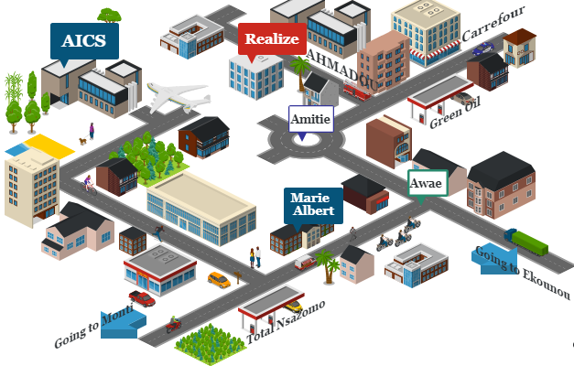

Figure 1: Localization plan of Realize

## **ORGANIZATION OF REALIZE**

### **Administrative organization**

Realize if administratively organized as follows:

#### **The General management**

This is the highest level of the company, which takes care of the following:

* Proper functioning of each department;
* Define project strategies;
* Provide leadership and guidance to the company’s employees.
* Makes critical decision that could affect the company’s operations or reputation
* Severe as a point of contact for key stakeholders such as investors etc.

#### **Human resource department**

This department is in charge of the following:

* Recruitment and Hiring
* Acts as a liaison between employees and management;
* Manages employee compensation and benefits programs;
* Develops and implements company policies and procedures, ensuring compliance with employment laws and regulations.
* Manages administrative tasks related to employee records, data management, and HR systems

#### **Communication Department**

This department is in charge of the following:

* Handles public relations activities, which involve managing the company’s reputation and image;
* Responsible for crafting and delivering messages to external stakeholders such as customers etc.;
* It fosters effective communication within the company;
* They create and manages content across different platforms and channels;

#### **Department of Financial Affairs**

This department is in charge of the following:

* Responsible for developing and managing the company’s financial plans and budgets;
* Prepare and presents accurate and timely financial reports to management, stakeholders, and regulatory authorities;
* Responsible for managing cost and expenses within the organization;
* Ensures compliance with tax laws and regulations. Etc.

#### **Technical department**

This department is in charge of the following:

* Responsible for managing the company’s technological infrastructure, including networks, hardware;
* Play a role in managing and maintaining the company’s data;
* Responsible for implementing and maintaining cybersecurity measures tp protect the company’s digital assets from potential threats;
* Interacts with technology vendors and manages relationships with external service providers. Etc.

#### **Software Engineering Department**

This department is in charge of the following:

* Primarily responsible for developing software applications and systems;
* Responsible for maintaining and supporting software application throughout their lifecycle;
* Evaluation and realization of projects etc.

### **FUNCTIONAL ORGANIZATION OF REALIZE**

The functional branch of Realize is organized as follows

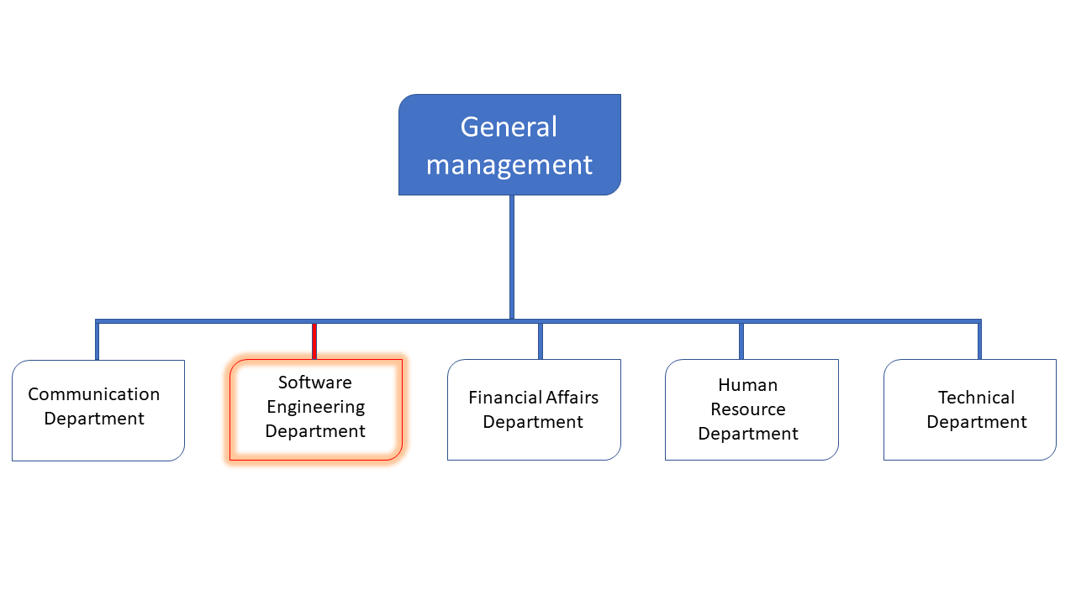

Figure 2: Functional organization of Realize

## **HARDWARE AND SOFWARE RESOURCES**

### **HARDWARE RESOURCES**

Table 1: Hardware resources

|  |  |  |  |  |
| --- | --- | --- | --- | --- |
| No | DESIGNATION | QUANTITY | CHARECTERISTICS | OBSERVATION |
| 1 | MacBook Pro | 1 | APPLE | Good |
| 2 | Modem | 1 | CAMTEL | Good |
| 3 | LCD Screen | 1 | HP | Excellent |
| 4 | Training equipment and office furniture | / | / |  |

### **SOFTWARE RESOURCES**

Table 2: Software resources

|  |  |
| --- | --- |
| DESIGNATION | SOFTWARE |
| Operating System | Windows 10, Mac OS, parrot Linux |
| Design tools | Photoshop |
| Integrated development environment (IDE) | Visual studio code |
| Text editor | Sublime text, notepad++ |
| Database management system (DBMS) | MongoDB, PostgreSQL, MySQL |
| Web browser | Google chrome, Microsoft edge |
| Document editor | Microsoft office word |

## **BRIEF PRESENTATION OF PROJECT**

At the end of the initial two weeks (insertion period), we received a topic, namely **CONCEPTION AND REALISATION OF A SERVICE DELIVERY APP.** This project entails the development of a comprehensive digital platform designed to seamlessly connect customers requiring diverse delivery services with verified providers and couriers.

The primary objective of the application is to **streamline the entire service delivery lifecycle** – from instant booking and real-time tracking to secure payment and feedback – creating an efficient, transparent, and user-friendly experience for both end-users (customers) and service providers.

## **CONCLUSION**

Our integration into the company was a pleasurable experience, with friendly and approachable colleagues and a professional supervisor who made us feel welcomed. Their availability and smooth integration into the company's operations were commendable. One of the most valuable takeaways from this phase was the importance of collaboration and discipline, crucial to any successful career. The subsequent phase of this momentous journey involves the project specifications, which must be precise and succinct to comprehensively understand what is needed to extract the most value from this transformative project.

# **PART 2: TECHNICAL PHASE**

# Preamble

The Technical phase helped us to establish a comprehensive understanding of the host organization. This phase emphasizes on the key characteristics, specificities, and objectives of the designated study subject.

# Content:

INTRODUCTION

1. The Existing System
2. The Specification Book
3. The Analysis Phase
4. The Conception Phase
5. Deployment or Realization Phase
6. The Functionality Phase
7. The User Guide

CONCLUSION

# **FILE 1 : EXISTING SYSTEM**

# Preamble

The existing system refers to the established processes currently used. This documentation outlines how these processes function, including their limitations and any resulting problems. We aim to address these issues by proposing a new solution.

# Content

INTRODUCTION

I. PRESENTATION OF THE THEME

II. DESCRIPTION OF THE EXISTING SYSTEM

III. CRITICISM OF THE EXISTING SYSTEM

IV. PROBLEMATIC

V. LIMITATIONS OF THE EXISTING SYSTEM

VI. PROPOSED SOLUTIONS

CONCLUSION

# **FILE 2 : THE SPECIFICATION BOOK**

# Preamble

This is a document that frames the student’s academic internship, specifies the behavior of the student during his internship. This stage involves organization, planning, pedagogical standards and monitoring of work. It is considered as a communication and description tool which permits us to avoid inadequate results.

# Content

INTRODUCTION

1. CONTEXT AND JUSTIFICATION OF PROJECT
2. PROJECT OBJECTIVES
3. EXPRESSION OF NEEDS

IV PROJECT PLANNING

1. ESTIMATED COST OF PROJECT

VI PARTICIPANTS

VII PROJECT CONSTRAINTS

VIII. DELIVERABLES

CONCLUSION

# **FILE 3 : ANALYSIS PHASE**

# Preamble

The analysis file following the specifications represents a more detailed explanation of the problem and the solution with the help of diagrams, the chosen analysis method to be used throughout the project and the reason for this choice. All these globs to having a better understanding of the information system to be modeled.

# Content

INTRODUCTION

I. METHODOLOGY

a) COMPARATIVE STUDIES BETWEEN MERISE AND UML

b) PRESENTATION OF THE 2TUP

c) CHARACTERISTICS OF 2TUP

d) JUSTIFICATION OF THE CHOICE OF THE ANALYSIS

II. MODELING

a) USE CASE DIAGRAM

b) COMMUNICATION DIAGRAM

c) SEQUENCE DIAGRAM

d) ACTIVITY DIAGRAM

CONCLUSION

# **FILE 4 : CONCEPTION PHASE**

# Preamble

This document makes it possible to model the proposed solution as a whole and to gather the information necessary to set up a complex and efficient database. It therefore foresees the future system.

# Content

INTRODUCTION

1. CAPTURE OF TECHNICAL NEEDS
2. CLASS DIAGRAM
3. STATE MACHINE DIAGRAM
4. PACKAGE DIAGRAM

CONCLUSION

# **FILE 5 : REALIZATION PHASE**

# Preamble

The realization document consists of the implementation of the project in a programming language according to the specifications defined in the previous file. It contains component and deployment diagrams; the testing and development phases. At the end of this part, programming documentation will be produced explaining the architecture of the database and the architecture of our code.

# Content

INTRODUCTION

I. DEPLOYEMENT DIAGRAM

II. COMPONENT DIAGRAM

III. TECHNICALCHOICES

CONCLUSION

# **FILE 6 : FUNCTIONALITY TESTING PHASE**

# Preamble

This phase aims at testing the software or application to verify if the system is working as expected. It involves testing individual functionalities and capabilities of the software to ensure that they work correctly and meet the specified needs.

# Content

INTRODUCTION

I. APPLICATION MODULES

II. TESTING

CONCLUSION

# **FILE 7 : THE USER GUIDE**

# Preamble

A user guide explains how to use a software application in a language that a non- a technical person can understand. Thus, it enables the user to easily use the application to familiarize themselves with the software and discover all its functionalities.

# Content

INTRODUCTION

1. DESCRIPTION OF THE APPLICATION
2. USER MANUAL

CONCLUSION

**GENERAL CONCLUSION**

# **ANNEXES**

# **BIBLIOGRAPHY**

**WEBOGRAPHY**

# **VIDEOGRAPHY**

# **TABLE OF CONTENT**